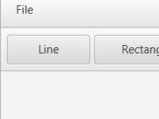To draw a line, click Line button next to the rectangle button in the top left, draw a line with mouse in the direction you want.

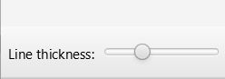

You can adjust the line thickness by dragging from the line thickness bar at the bottom left.

metin, elektronik eşyalar, ekran görüntüsü içeren bir resim

Açıklama otomatik olarak oluşturuldu

You can adjust the color of the line or rectangle yourself by entering numbers (max 255) on the RGB buttons at the bottom and clicking the color button.

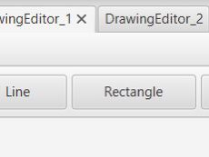

To draw a rectangle, click Rectangle button next to the line button in the top left, draw a line with mouse in the direction you want.

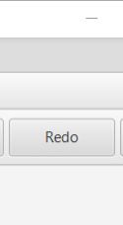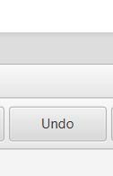 Undo button erases the last change done to the application, reverting it to an older version. You can use redo button to reverse your last undo you can reverse more than one action that has been undone. You can use Redo command only after Undo command.

